____ USBC Headphones for classroom use

____ 1 hard **plastic pencil** box

____ 24 pencils (sharpened)

____ 2 spiral notebooks (**wide ruled no decorations**)

____ 4 boxes of 24 count **Crayola** crayons

____ 12 Elmer's glue sticks

____ 1 binder (1 inch white with clear view front)

____ 1 pair of child's Fiskars blunt tipped scissors

**BOYS**

____ 1 container of Clorox wipes ____ 1 box of snack sized Ziplock bags

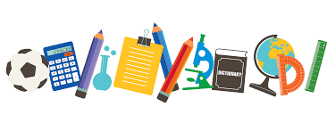

____ 1 box of tissues

____ 1 composition notebook

____ 1 bottle of **antibacterial** hand soap

____ 1 pack of **BLACK** Expo dry erase

markers (chisel point)

____ 1 pack of **BLACK** Expo dry erase

markers (fine point)

____ Paper Mate Pink Pearl Erasers

(not pencil tops)

**GIRLS**

____ 1 box of quart sized Ziplock bags

____ 1 bottle of hand sanitizer